Comparisons between different Algorithms

1.A2C

2.PPO

3.DDPG

4.Ensemble Method

**Where all the above 3 algorithms are tried in a window of 3 months and the best performing algo is taken up wrt to sharpe ratio**

4. Compare the Weights with alpha value

Link to Updated Weights of Portfolio on a daily basis: <https://docs.google.com/spreadsheets/d/1dsTpLI_W9sFiLRG47f3-gythDtzSENVUDhGofhWjO3o/edit?usp=sharing>

Link to returns of Portfolio on a daily basis :

<https://docs.google.com/spreadsheets/d/1GJsU3BfZPY6aDqQnFZwAhN5BMLcHke1jcmNUnt5TweA/edit?usp=sharing>

**Training Period : 2009-01-01 to 2020-07-01**

**Testing : 2020-01-01 to 2021-10-31**

|  | **A2C** | **PPO** | **DDPG** | **DJI(Baseline)** | **Ensemble** | **Min Variance** |
| --- | --- | --- | --- | --- | --- | --- |
| **Cumulative returns** | **0.33009** | **0.369228** | **0.36576** | **0.3918402** | **0.221975** | **0.279764** |
| **Annual return** | **0.237854** | **0.263509** | **0.260639** | **0.279047** | **0.221975** | **0.202566** |
| **Sharpe ratio** | **1.645981** | **1.776876** | **1.726857** | **1.844560** | **1.494542** | **1.754163** |
| **Annual volatility** | **0.135233** | **0.136952** | **0.139828** | **0.139129** | **0.143199** | **0.108546** |
| Max drawdown | -0.087796 | -0.091962 | 0.139828 | -0.091962 | -0.080661 | Max drawdown -0.071326 |

# Combined

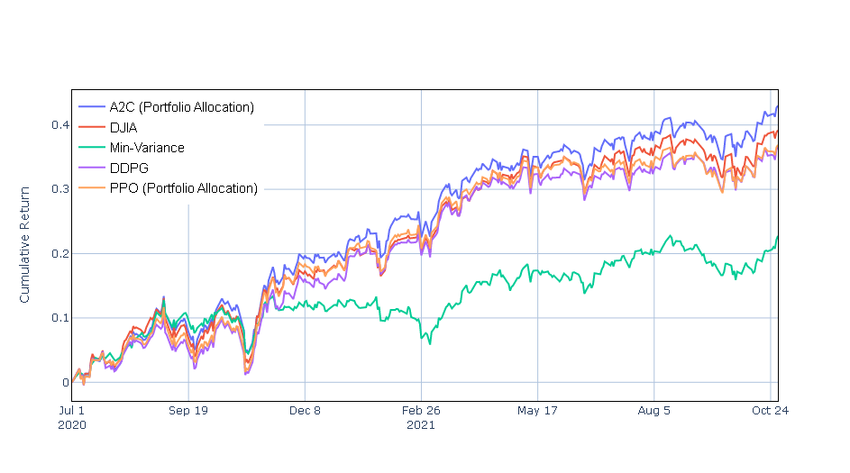

# A2C

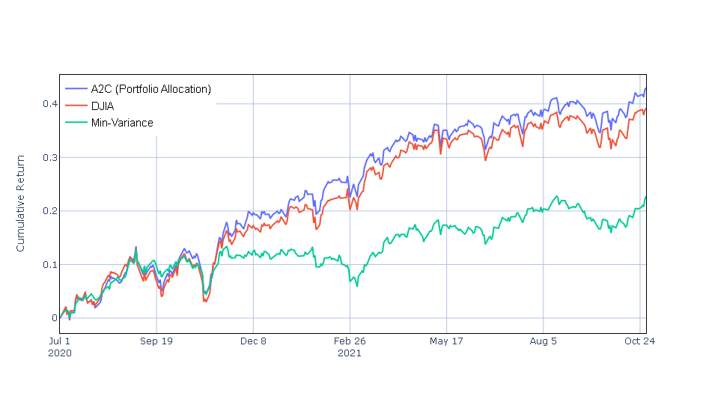

# PPO

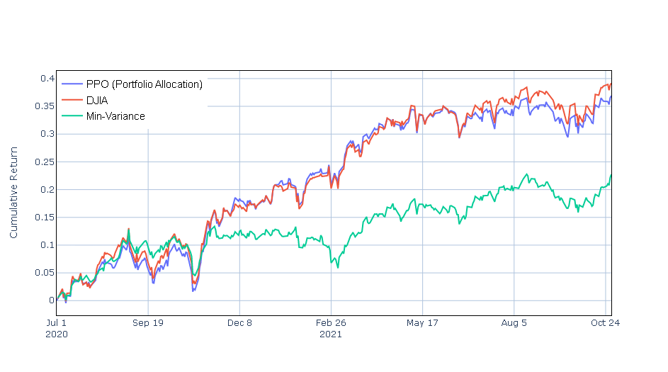

# 

# DDPG

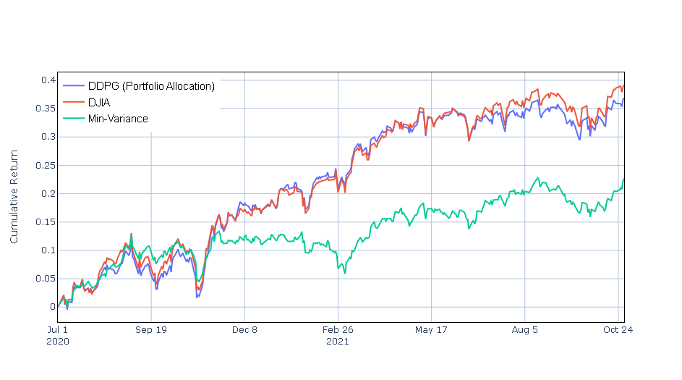

# 

# Ensemble

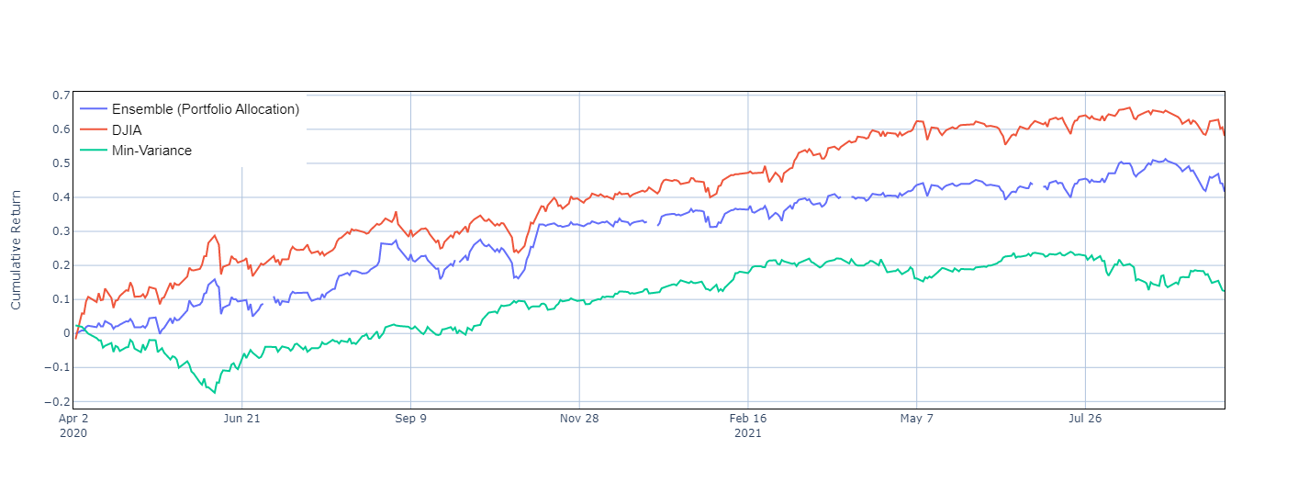

|  | **A2C** | **PPO** | **DDPG** | **DJI(Baseline)** | **Ensemble** | **MIn Variance** |
| --- | --- | --- | --- | --- | --- | --- |
| **Cumulative returns** | **0.330231** | **0.367228** | **0.363076** | **0.388402** | **0.416702** | **0.279764** |
| **Annual return** | **0.237854** | **0.263509** | **0.260639** | **0.279047** | **0.261399** | **0.202566** |
| **Sharpe ratio** | **1.645981** | **1.776876** | **1.726857** | **1.844560** | **1.442334** | **1.754163** |
| **Annual volatility** | **0.135233** | **0.136952** | **0.139828** | **0.139129** | **0.174200** | **0.108546** |
| Max drawdown | -0.087796 | -0.091962 | 0.139828 | -0.091962 | -0.094090 | Max drawdown -0.071326 |

Ensemble

Annual return 0.261399

Cumulative returns 0.416702

Annual volatility 0.174200

Sharpe ratio 1.442334

Calmar ratio 2.778173

Stability 0.912463

Max drawdown -0.094090

Omega ratio 1.300572

Sortino ratio 2.108885

Skew NaN

Kurtosis NaN

Tail ratio 1.118146

Daily value at risk -0.020950

Alpha 0.000000

Beta 1.000000

A2C

Annual return 0.262516

Cumulative returns 0.365791

Annual volatility 0.136757

Sharpe ratio 1.773551

Calmar ratio 3.094517

Stability 0.904298

Max drawdown -0.084833

Omega ratio 1.340333

Sortino ratio 2.639681

Skew -0.271747

Kurtosis 0.819941

Tail ratio 1.104419

Daily value at risk -0.016267

Alpha 0.000000

Beta 1.000000

dtype: float64

Baseline DJI

Shape of DataFrame: (336, 8)

Annual return 0.279047

Cumulative returns 0.388402

Annual volatility 0.139129

Sharpe ratio 1.844560

Calmar ratio 3.124551

Stability 0.918675

Max drawdown -0.089308

Omega ratio 1.358960

Sortino ratio 2.734872

Skew NaN

Kurtosis NaN

Tail ratio 1.052781

Daily value at risk -0.016510

PPO

Annual return 0.263509

Cumulative returns 0.367228

Annual volatility 0.136952

Sharpe ratio 1.776876

Calmar ratio 2.865421

Stability 0.915793

Max drawdown -0.091962

Omega ratio 1.345316

Sortino ratio 2.714634

Skew -0.047473

Kurtosis 1.396755

Tail ratio 1.069301

Daily value at risk -0.016289

Alpha 0.000000

Beta 1.000000

DDPG

Annual return 0.260639

Cumulative returns 0.363076

Annual volatility 0.139828

Sharpe ratio 1.726857

Calmar ratio 2.932645

Stability 0.887403

Max drawdown -0.088875

Omega ratio 1.334106

Sortino ratio 2.638032

Skew 0.027132

Kurtosis 2.130388

Tail ratio 1.101187

Daily value at risk -0.016658

Alpha 0.000000

Beta 1.000000

Ensemble Method

Annual return 0.221975

Cumulative returns 0.221975

Annual volatility 0.143199

Sharpe ratio 1.494542

Calmar ratio 2.751962

Stability 0.867752

Max drawdown -0.080661

Omega ratio 1.292614

Sortino ratio 2.148736

Skew NaN

Kurtosis NaN

Tail ratio 1.061773

Daily value at risk -0.017192

Alpha 0.000000

Beta 1.000000

dtype: float64

Min Variance

Annual return 0.202566

Cumulative returns 0.279764

Annual volatility 0.108546

Sharpe ratio 1.754163

Calmar ratio 2.840016

Stability 0.876161

Max drawdown -0.071326

Omega ratio 1.337016

Sortino ratio 2.551755

Skew -0.461492

Kurtosis 1.403840

Tail ratio 0.999370

Daily value at risk -0.012920

Report Flow

Story:

1.Abstract :

Conventional Method:

Markowitz: Basic and simple (Noble Prize)

{Want to take it forward}

min variance method:

----In big datasets,

Momentum based for short term using hurst exponent

RSI: prediction happening using ARIMA

Long Term: Mean Variance

DRL strategy: PPO, DDPG, A2C, Ensemble

Eigenvesting

:Connecting Idea between RL and Eigenvectors

Abstract:

Together

**CHAPTER-1**

INTRODUCTION and **THESIS OVERVIEW**

Another method for determining the best stock trading strategy is to represent it as a Markov Decision Process (MDP) and use dynamic programming to find it [4, 5]. However, the scalability of this model is limited due to the large state spaces when dealing with the stock market.A state-space is defined as a set of all possible states of a problem.